ASSIGNMENT NO.12: MINI PROJECT – TRAINING INSTITUTE MANAGEMENT SYSTEM
Student Name | Aditya Ballal | Roll Number | 20966
Batch | SY. BSc Data Science | Topic | WB(Assignment-11)

1. Objective
Develop a basic MySQL Training Institute Management System to manage students, trainers, courses, batches, enrollments, attendance, and assessment results. The project demonstrates database planning, table relationships, query writing, business analysis, and presentation of findings.

2. Requirement Analysis and Project Planning
- Study how a training institute manages students, trainers, courses, batches, attendance, and assessment results.
- Identify the main users: administrator, trainer, and institute coordinator.
- Define the information stored for each business activity.
- Prepare functional requirements and identify the main reports expected from the database.
- Use realistic sample data representing a training institute.

3. Functional Requirements
- Maintain student registration and contact information.
- Maintain course details such as duration, fee, and level.
- Maintain trainer details, specialization, and experience.
- Create batches for courses and assign trainers.
- Enroll students into batches.
- Record attendance for each enrolled student and training session.
- Record assessment results for enrolled students.
- Generate reports for enrollment, attendance, performance, and training progress.

4. ER Diagram
The ER diagram follows the seven-table structure and relationship requirements specified in the supplied Assignment No. 12. It uses the same textbook-style notation as the supplied reference image.
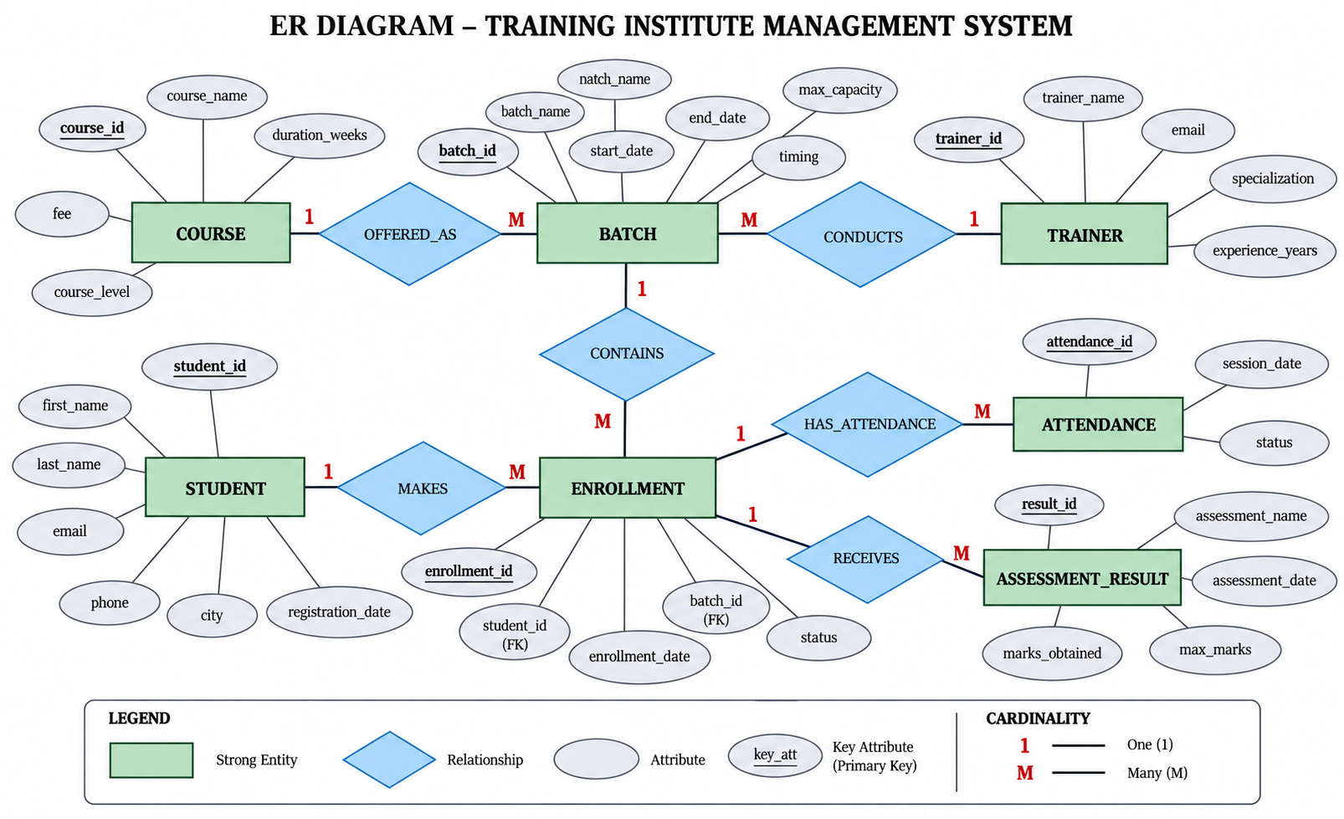
Figure 1: ER Diagram – Training Institute Management System

5. Database Schema Diagram

The table schema below follows the same schema-diagram approach shown in the supplied reference image. It represents the seven required entities in the Training Institute Management System and shows each column, data type, primary key, and foreign-key relationship.

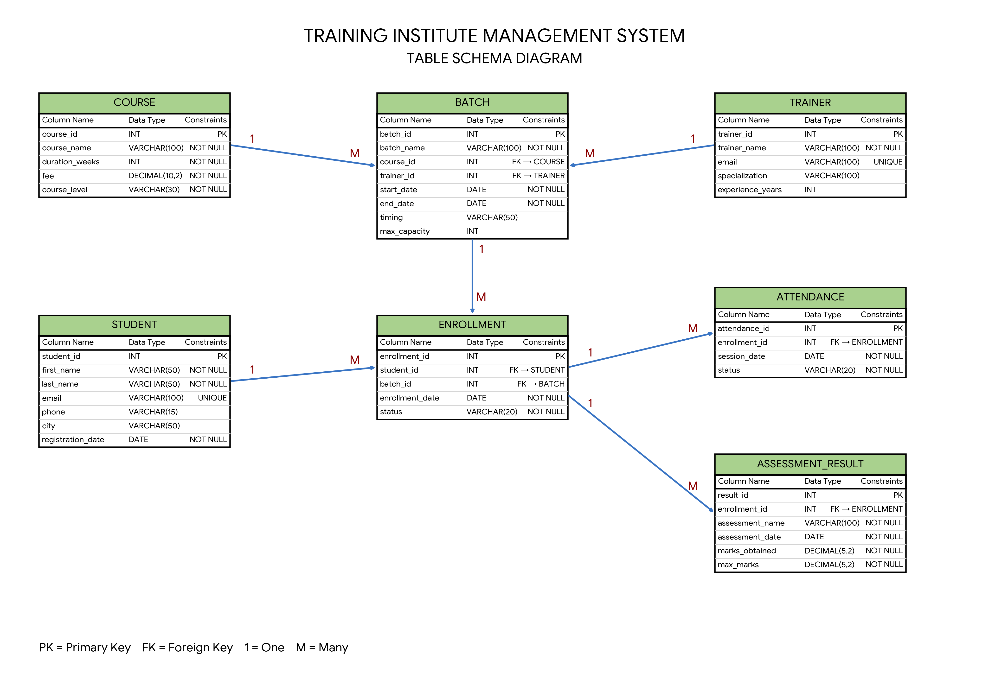

Figure 2: Table Schema Diagram – Training Institute Management System

Schema interpretation: Course and Trainer are parent tables for Batch. Batch connects the selected course and trainer. Enrollment connects Student with Batch. Attendance and AssessmentResult store repeated records for each enrollment. Therefore, the foreign keys shown in the schema directly implement the relationships shown in the ER diagram.

5. Entities and Attributes
Entity | Attributes
Student | student_id (PK), first_name, last_name, email, phone, city, registration_date
Trainer | trainer_id (PK), trainer_name, email, specialization, experience_years
Course | course_id (PK), course_name, duration_weeks, fee, course_level
Batch | batch_id (PK), batch_name, course_id (FK), trainer_id (FK), start_date, end_date, timing, max_capacity
Enrollment | enrollment_id (PK), student_id (FK), batch_id (FK), enrollment_date, status
Attendance | attendance_id (PK), enrollment_id (FK), session_date, status
AssessmentResult | result_id (PK), enrollment_id (FK), assessment_name, assessment_date, marks_obtained, max_marks

6. Table Relationships and Cardinality
Parent Table | Related Table | Relationship | Purpose
Course | Batch | 1 : M | One course can be conducted through multiple batches.
Trainer | Batch | 1 : M | One trainer can handle multiple batches.
Student | Enrollment | 1 : M | One student can have multiple enrollments.
Batch | Enrollment | 1 : M | One batch can contain multiple student enrollments.
Enrollment | Attendance | 1 : M | One enrollment can have multiple attendance records.
Enrollment | AssessmentResult | 1 : M | One enrolled student can receive multiple assessment results.

7. Primary Keys and Foreign Keys
Table | Primary Key | Foreign Key(s)
Course | course_id | —
Trainer | trainer_id | —
Batch | batch_id | course_id → Course.course_id; trainer_id → Trainer.trainer_id
Student | student_id | —
Enrollment | enrollment_id | student_id → Student.student_id; batch_id → Batch.batch_id
Attendance | attendance_id | enrollment_id → Enrollment.enrollment_id
AssessmentResult | result_id | enrollment_id → Enrollment.enrollment_id

8. Relational Schema / Table Structure

Student
Column | Data Type | Constraint
student_id | INT | PRIMARY KEY
first_name | VARCHAR(50) | NOT NULL
last_name | VARCHAR(50) | NOT NULL
email | VARCHAR(100) | NOT NULL, UNIQUE
phone | VARCHAR(15)
city | VARCHAR(50)
registration_date | DATE | NOT NULL

Course
Column | Data Type | Constraint
course_id | INT | PRIMARY KEY
course_name | VARCHAR(100) | NOT NULL
duration_weeks | INT | NOT NULL
fee | DECIMAL(10,2) | NOT NULL
course_level | VARCHAR(30) | NOT NULL

Trainer
Column | Data Type | Constraint
trainer_id | INT | PRIMARY KEY
trainer_name | VARCHAR(100) | NOT NULL
email | VARCHAR(100) | NOT NULL, UNIQUE
specialization | VARCHAR(100)
experience_years | INT

Batch
Column | Data Type | Constraint
batch_id | INT | PRIMARY KEY
batch_name | VARCHAR(100) | NOT NULL
course_id | INT | NOT NULL, FK
trainer_id | INT | NOT NULL, FK
start_date | DATE | NOT NULL
end_date | DATE | NOT NULL
timing | VARCHAR(50)
max_capacity | INT

Enrollment
Column | Data Type | Constraint
enrollment_id | INT | PRIMARY KEY
student_id | INT | NOT NULL, FK
batch_id | INT | NOT NULL, FK
enrollment_date | DATE | NOT NULL
status | VARCHAR(20) | NOT NULL

Attendance
Column | Data Type | Constraint
attendance_id | INT | PRIMARY KEY
enrollment_id | INT | NOT NULL, FK
session_date | DATE | NOT NULL
status | VARCHAR(20) | NOT NULL

AssessmentResult
Column | Data Type | Constraint
result_id | INT | PRIMARY KEY
enrollment_id | INT | NOT NULL, FK
assessment_name | VARCHAR(100) | NOT NULL
assessment_date | DATE | NOT NULL
marks_obtained | DECIMAL(5,2) | NOT NULL
max_marks | DECIMAL(5,2) | NOT NULL

9. MySQL Database Creation and Table Creation
This script creates the database and the seven tables shown in the ER diagram.
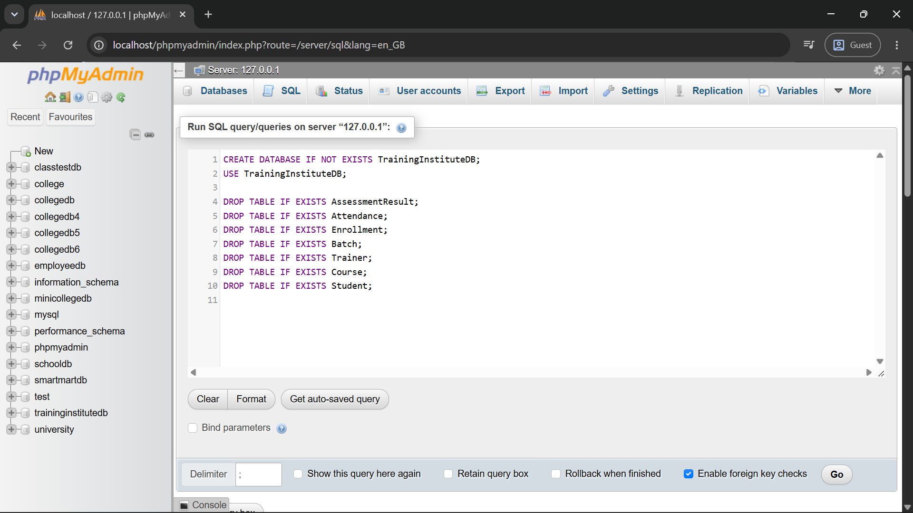
CREATE DATABASE IF NOT EXISTS TrainingInstituteDB;
USE TrainingInstituteDB;
DROP TABLE IF EXISTS AssessmentResult;
DROP TABLE IF EXISTS Attendance;
DROP TABLE IF EXISTS Enrollment;
DROP TABLE IF EXISTS Batch;
DROP TABLE IF EXISTS Trainer;
DROP TABLE IF EXISTS Course;
DROP TABLE IF EXISTS Student;
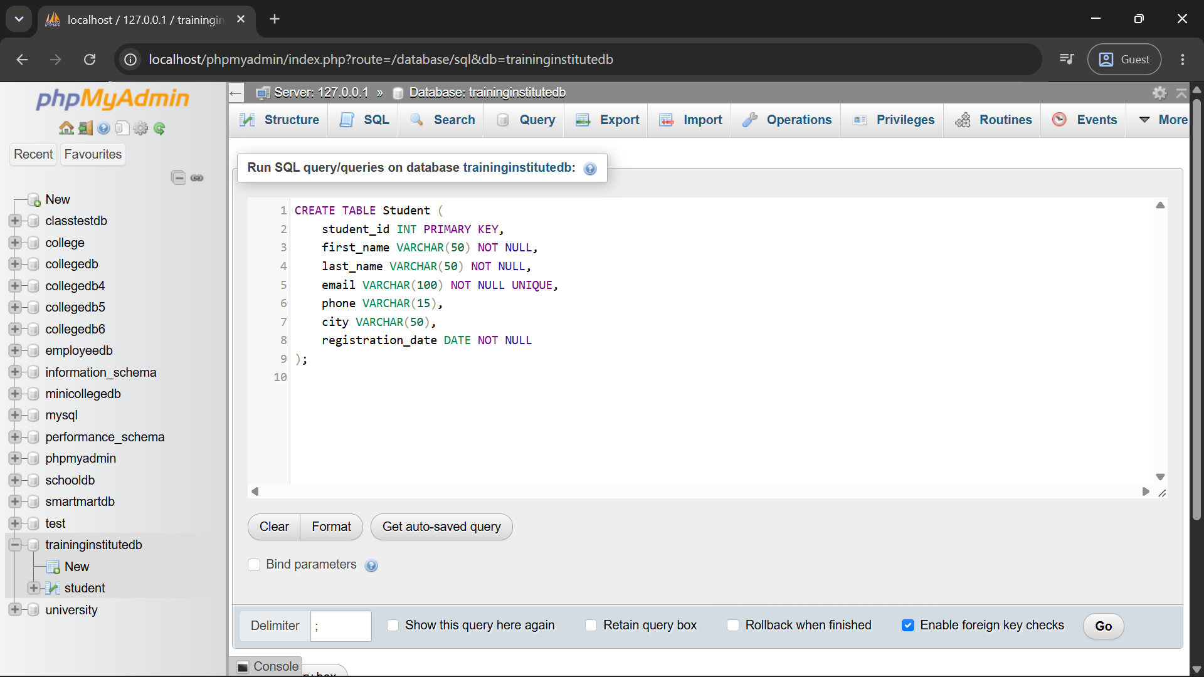
CREATE TABLE Student (
student_id INT PRIMARY KEY,
first_name VARCHAR(50) NOT NULL,
last_name VARCHAR(50) NOT NULL,
email VARCHAR(100) NOT NULL UNIQUE,
phone VARCHAR(15),
city VARCHAR(50),
registration_date DATE NOT NULL
);
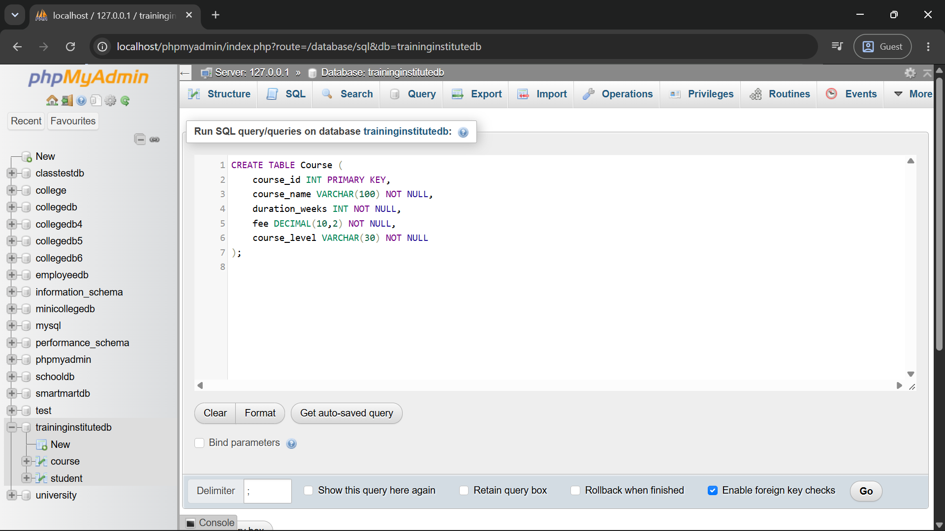
CREATE TABLE Course (
course_id INT PRIMARY KEY,
course_name VARCHAR(100) NOT NULL,
duration_weeks INT NOT NULL,
fee DECIMAL(10,2) NOT NULL,
course_level VARCHAR(30) NOT NULL
);
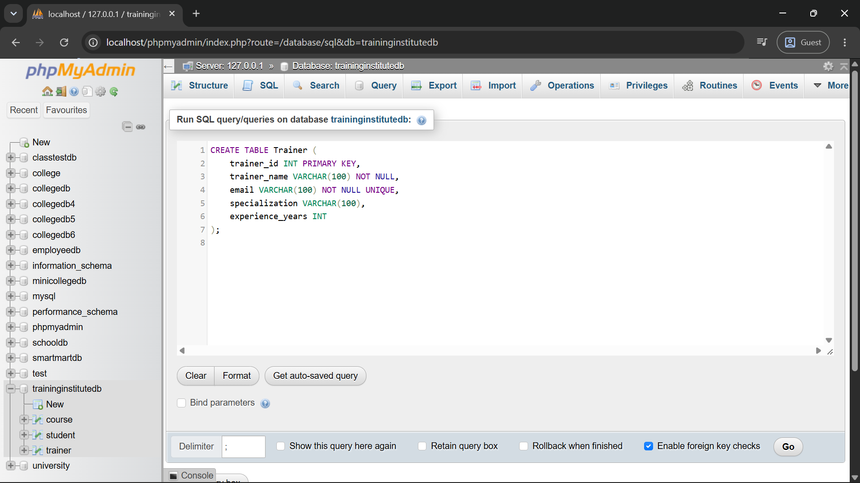
CREATE TABLE Trainer (
trainer_id INT PRIMARY KEY,
trainer_name VARCHAR(100) NOT NULL,
email VARCHAR(100) NOT NULL UNIQUE,
specialization VARCHAR(100),
experience_years INT
);
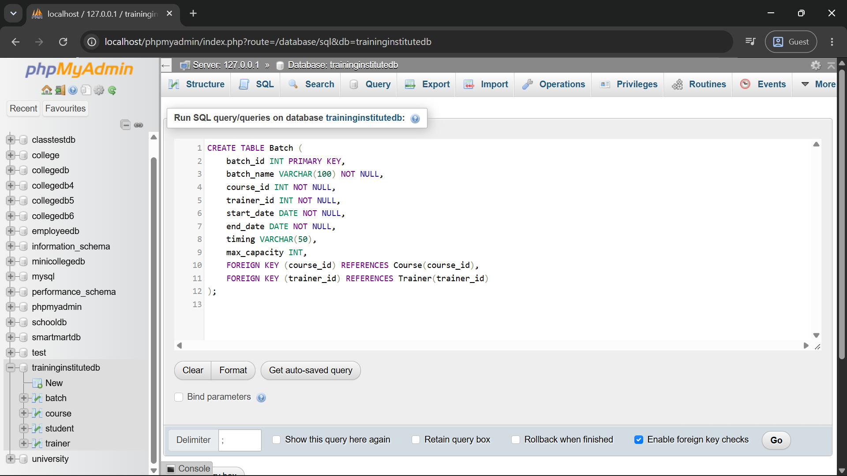
CREATE TABLE Batch (
batch_id INT PRIMARY KEY,
batch_name VARCHAR(100) NOT NULL,
course_id INT NOT NULL,
trainer_id INT NOT NULL,
start_date DATE NOT NULL,
end_date DATE NOT NULL,
timing VARCHAR(50),
max_capacity INT,
FOREIGN KEY (course_id) REFERENCES Course(course_id),
FOREIGN KEY (trainer_id) REFERENCES Trainer(trainer_id)
);
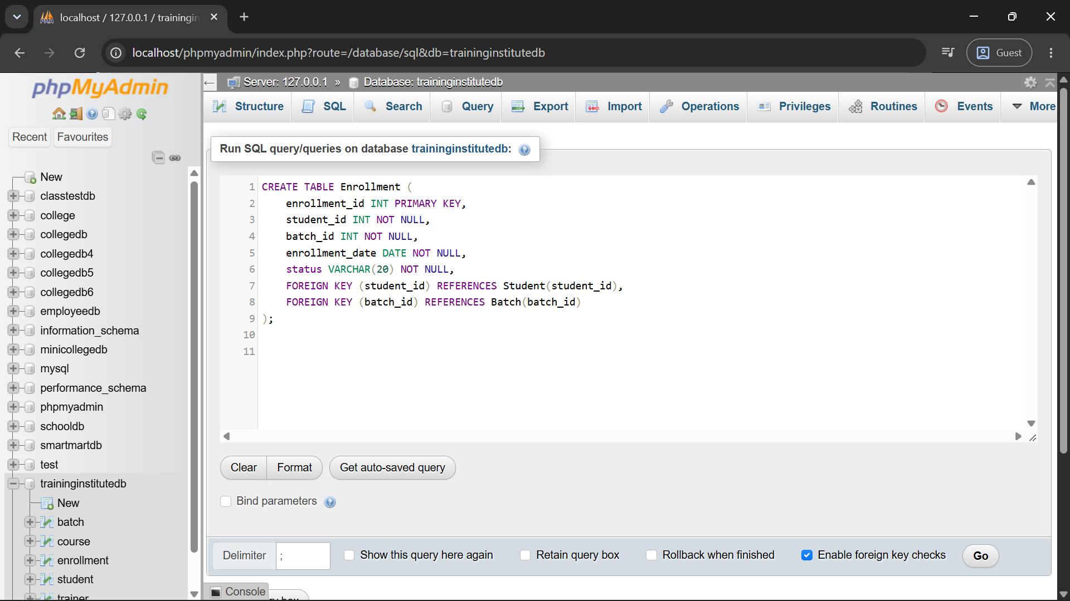
CREATE TABLE Enrollment (
enrollment_id INT PRIMARY KEY,
student_id INT NOT NULL,
batch_id INT NOT NULL,
enrollment_date DATE NOT NULL,
status VARCHAR(20) NOT NULL,
FOREIGN KEY (student_id) REFERENCES Student(student_id),
FOREIGN KEY (batch_id) REFERENCES Batch(batch_id)
);
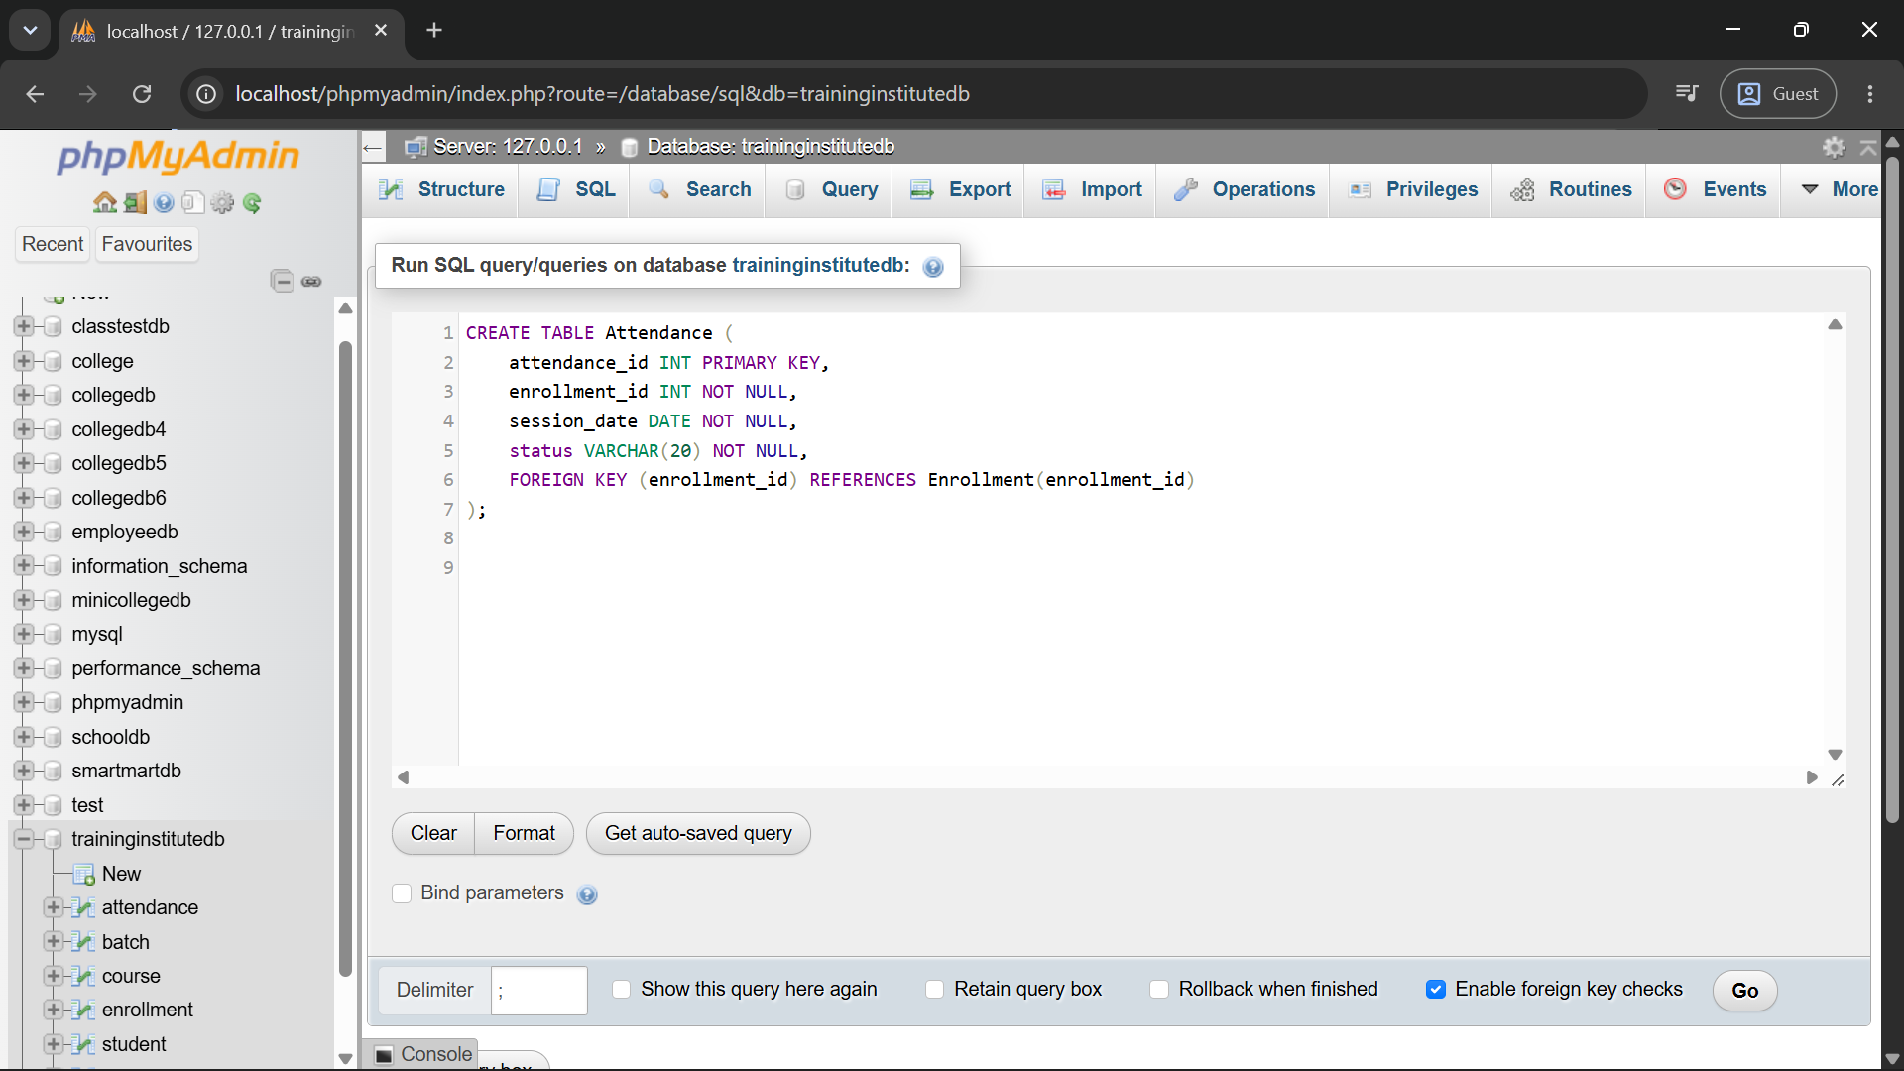
CREATE TABLE Attendance (
attendance_id INT PRIMARY KEY,
enrollment_id INT NOT NULL,
session_date DATE NOT NULL,
status VARCHAR(20) NOT NULL,
FOREIGN KEY (enrollment_id) REFERENCES Enrollment(enrollment_id)
);
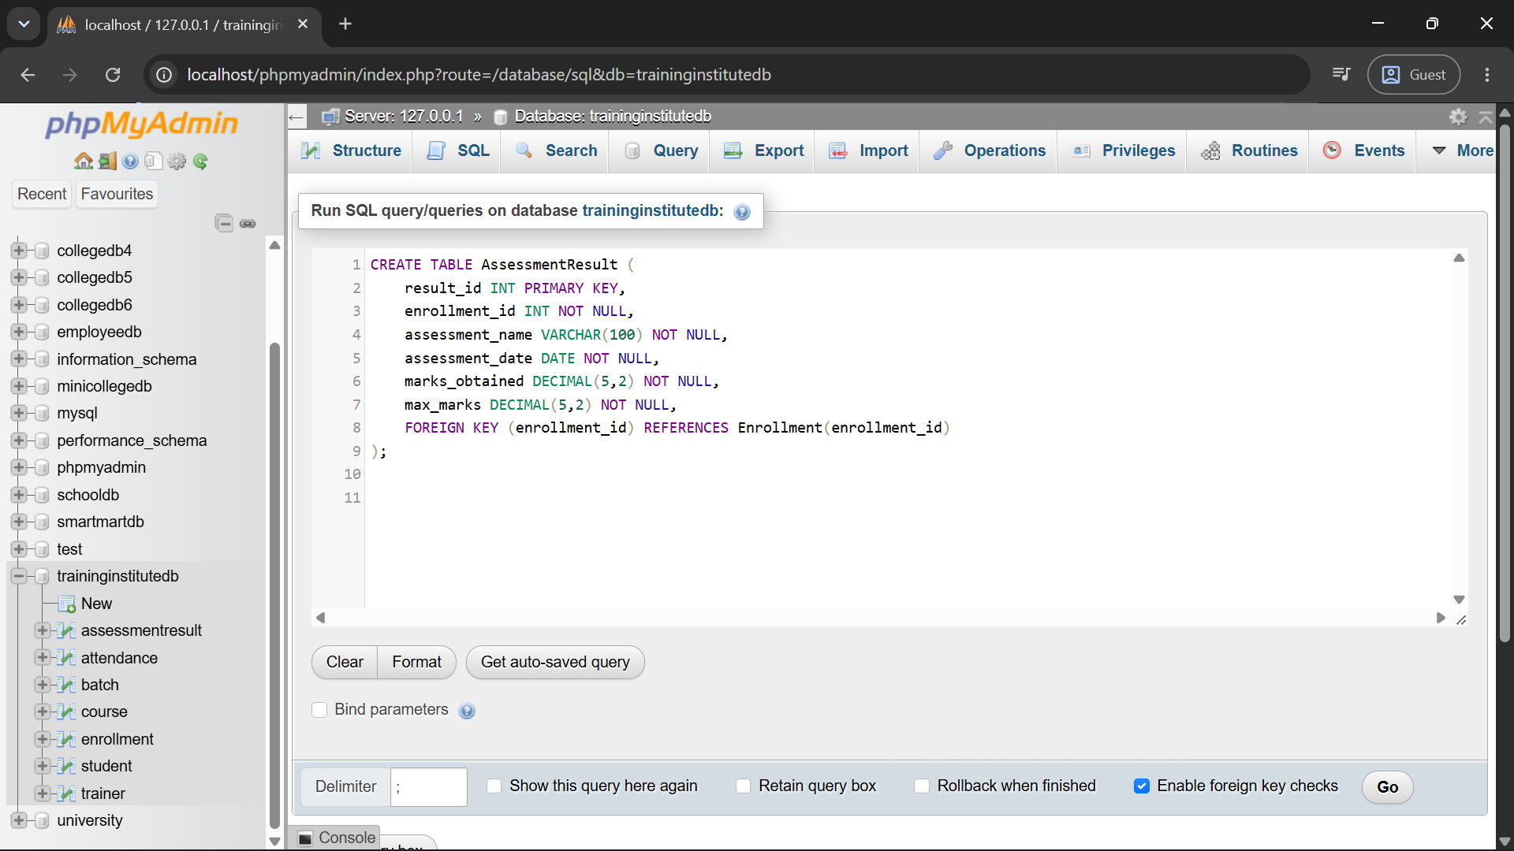
CREATE TABLE AssessmentResult (
result_id INT PRIMARY KEY,
enrollment_id INT NOT NULL,
assessment_name VARCHAR(100) NOT NULL,
assessment_date DATE NOT NULL,
marks_obtained DECIMAL(5,2) NOT NULL,
max_marks DECIMAL(5,2) NOT NULL,
FOREIGN KEY (enrollment_id) REFERENCES Enrollment(enrollment_id)
);

10. Sample Data
The project uses realistic sample records so that the required business questions can be tested.
Course ID | Course Name |  |  | Duration (Weeks) |  | Fee |  |  | Level
101 | Python Programming |  |  | 8 |  | 12000.00 |  |  | Beginner
102 | Data Analytics with SQL |  |  | 10 |  | 15000.00 |  |  | Intermediate
103 | Web Development |  |  | 12 |  | 18000.00 |  |  | Intermediate
104 | Data Science |  |  | 16 |  | 25000.00 |  |  | Advanced
Trainer ID |  | Trainer Name |  |  | Specialization |  |  | Experience (Years)
201 |  | Amit Kulkarni |  |  | Python & Data Science |  |  | 7
202 |  | Neha Joshi |  |  | SQL & Database |  |  | 6
203 |  | Rohan Patil |  |  | Web Development |  |  | 8
204 |  | Priya Deshmukh |  |  | Statistics & Data Science |  |  | 5
Batch ID | Batch Name |  |  | Course ID |  | Trainer ID |  |  | Start Date
301 | PY-JAN-26 |  |  | 101 |  | 201 |  |  | 2026-01-05
302 | SQL-MAR-26 |  |  | 102 |  | 202 |  |  | 2026-03-02
303 | WEB-APR-26 |  |  | 103 |  | 203 |  |  | 2026-04-06
304 | DS-JUL-26 |  |  | 104 |  | 204 |  |  | 2026-07-06
305 | PY-AUG-26 |  |  | 101 |  | 201 |  |  | 2026-08-03
Student ID |  |  | Student Name |  |  |  | City
1 |  |  | Aarav Shah |  |  |  | Mumbai
2 |  |  | Meera Joshi |  |  |  | Pune
3 |  |  | Rohan Patil |  |  |  | Nashik
4 |  |  | Sneha Kulkarni |  |  |  | Pune
5 |  |  | Kunal Mehta |  |  |  | Thane
6 |  |  | Ananya Sharma |  |  |  | Mumbai
7 |  |  | Vikram Desai |  |  |  | Pune
8 |  |  | Isha Nair |  |  |  | Nashik
9 |  |  | Aditya More |  |  |  | Pune
10 |  |  | Kavya Verma |  |  |  | Mumbai
Enrollment ID |  |  | Student ID |  |  |  | Batch ID
401 |  |  | 1 |  |  |  | 301
402 |  |  | 2 |  |  |  | 301
403 |  |  | 3 |  |  |  | 302
404 |  |  | 4 |  |  |  | 302
405 |  |  | 5 |  |  |  | 302
406 |  |  | 6 |  |  |  | 303
407 |  |  | 7 |  |  |  | 303
408 |  |  | 8 |  |  |  | 304
409 |  |  | 9 |  |  |  | 304
410 |  |  | 10 |  |  |  | 304
411 |  |  | 2 |  |  |  | 305
412 |  |  | 5 |  |  |  | 305

11. Business Queries and Data Analysis

Q1. Display all students enrolled in each batch.
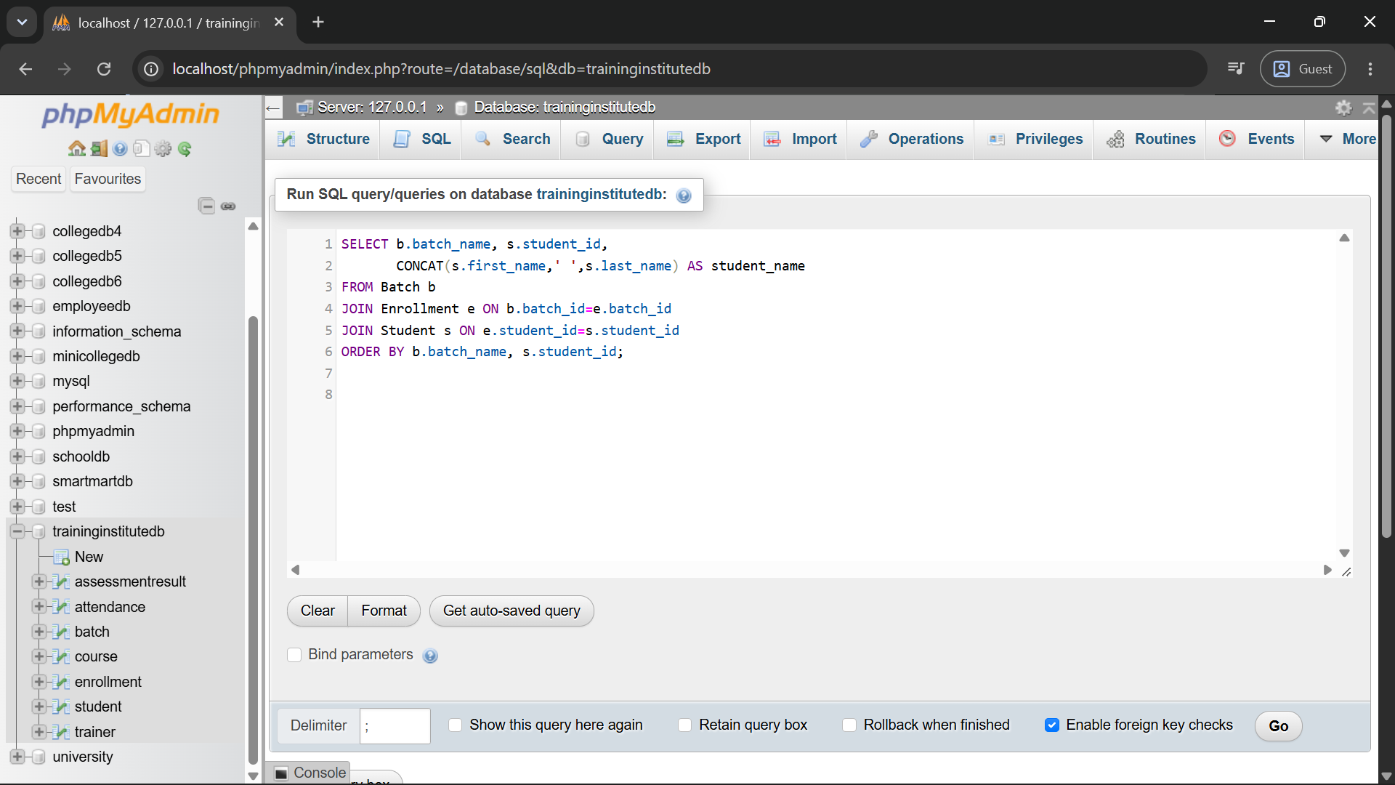
SELECT b.batch_name, s.student_id,
CONCAT(s.first_name,' ',s.last_name) AS student_name
FROM Batch b
JOIN Enrollment e ON b.batch_id=e.batch_id
JOIN Student s ON e.student_id=s.student_id
ORDER BY b.batch_name, s.student_id;

Q2. Display the course and trainer assigned to every batch.
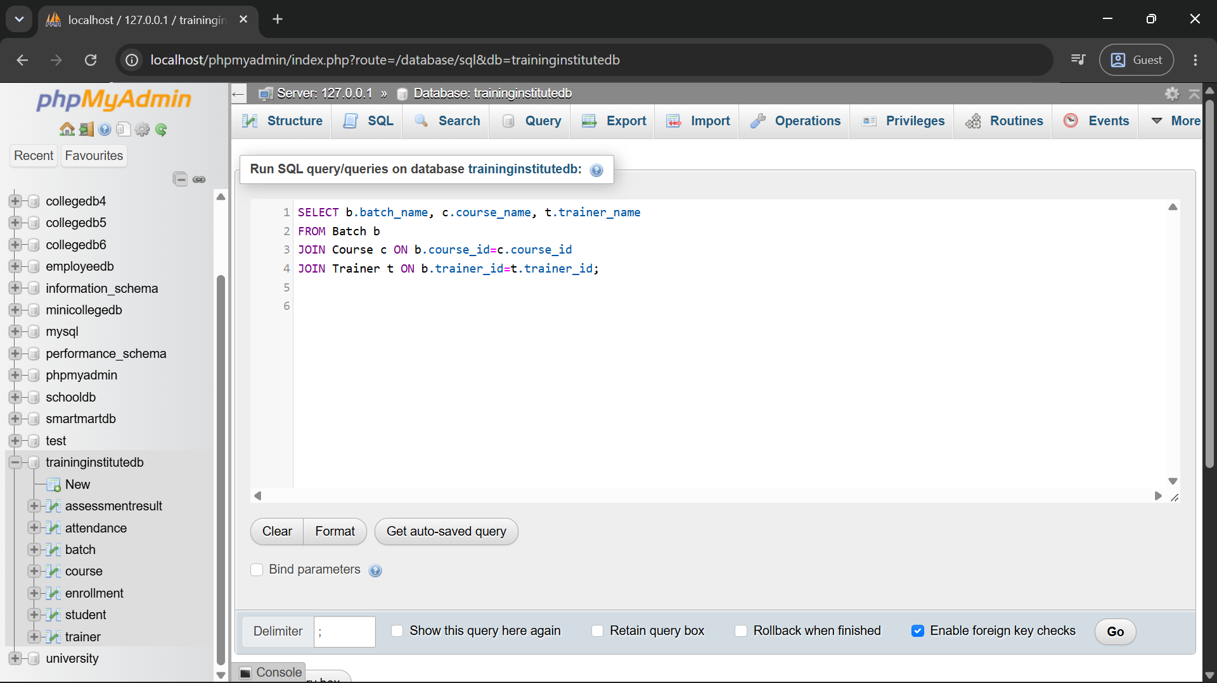
SELECT b.batch_name, c.course_name, t.trainer_name
FROM Batch b
JOIN Course c ON b.course_id=c.course_id
JOIN Trainer t ON b.trainer_id=t.trainer_id;

Q3. Find the total number of students in each course.
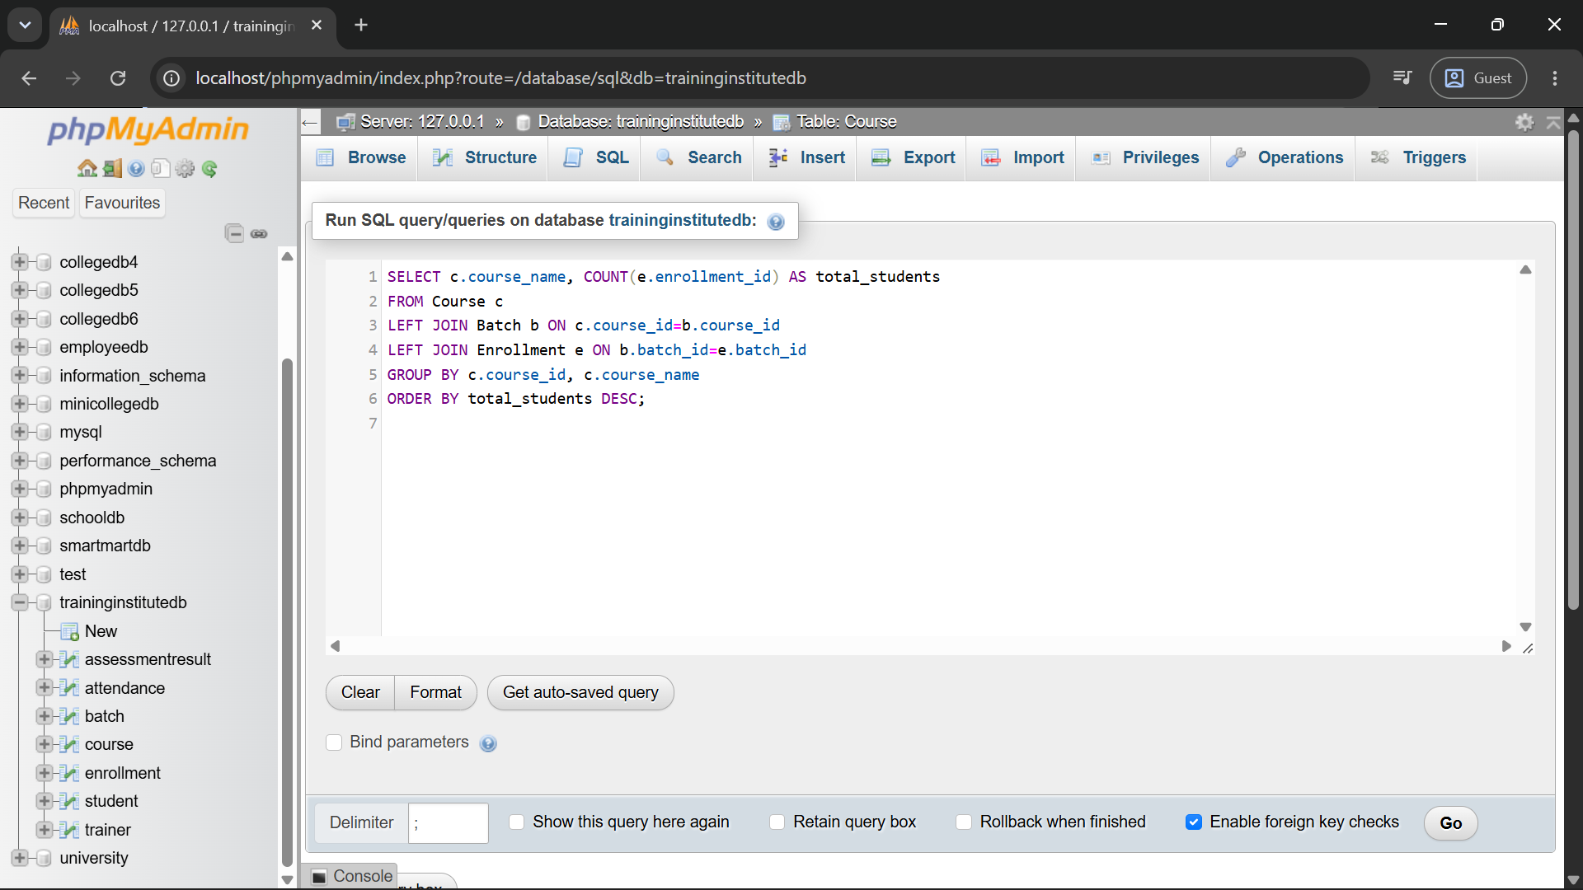
SELECT c.course_name, COUNT(e.enrollment_id) AS total_students
FROM Course c
LEFT JOIN Batch b ON c.course_id=b.course_id
LEFT JOIN Enrollment e ON b.batch_id=e.batch_id
GROUP BY c.course_id, c.course_name
ORDER BY total_students DESC;

Q4. Find batches having more than 2 students.
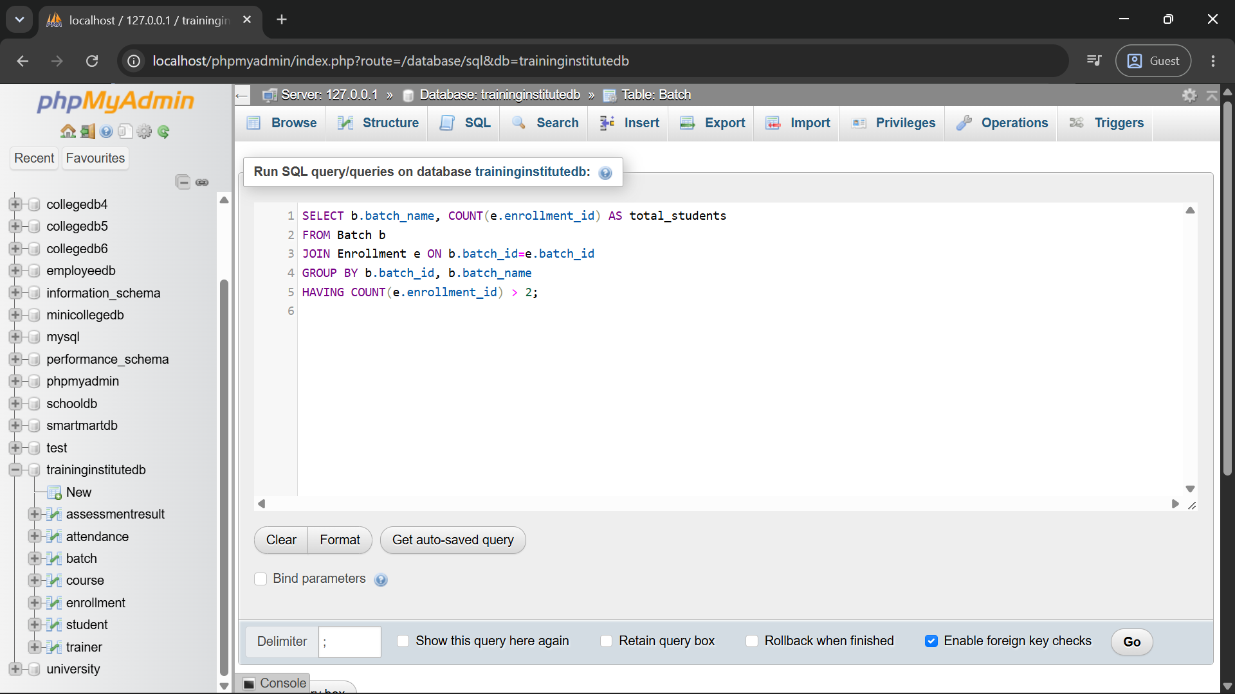
SELECT b.batch_name, COUNT(e.enrollment_id) AS total_students
FROM Batch b
JOIN Enrollment e ON b.batch_id=e.batch_id
GROUP BY b.batch_id, b.batch_name
HAVING COUNT(e.enrollment_id) > 2;

Q5. Display students whose attendance is below 75%.
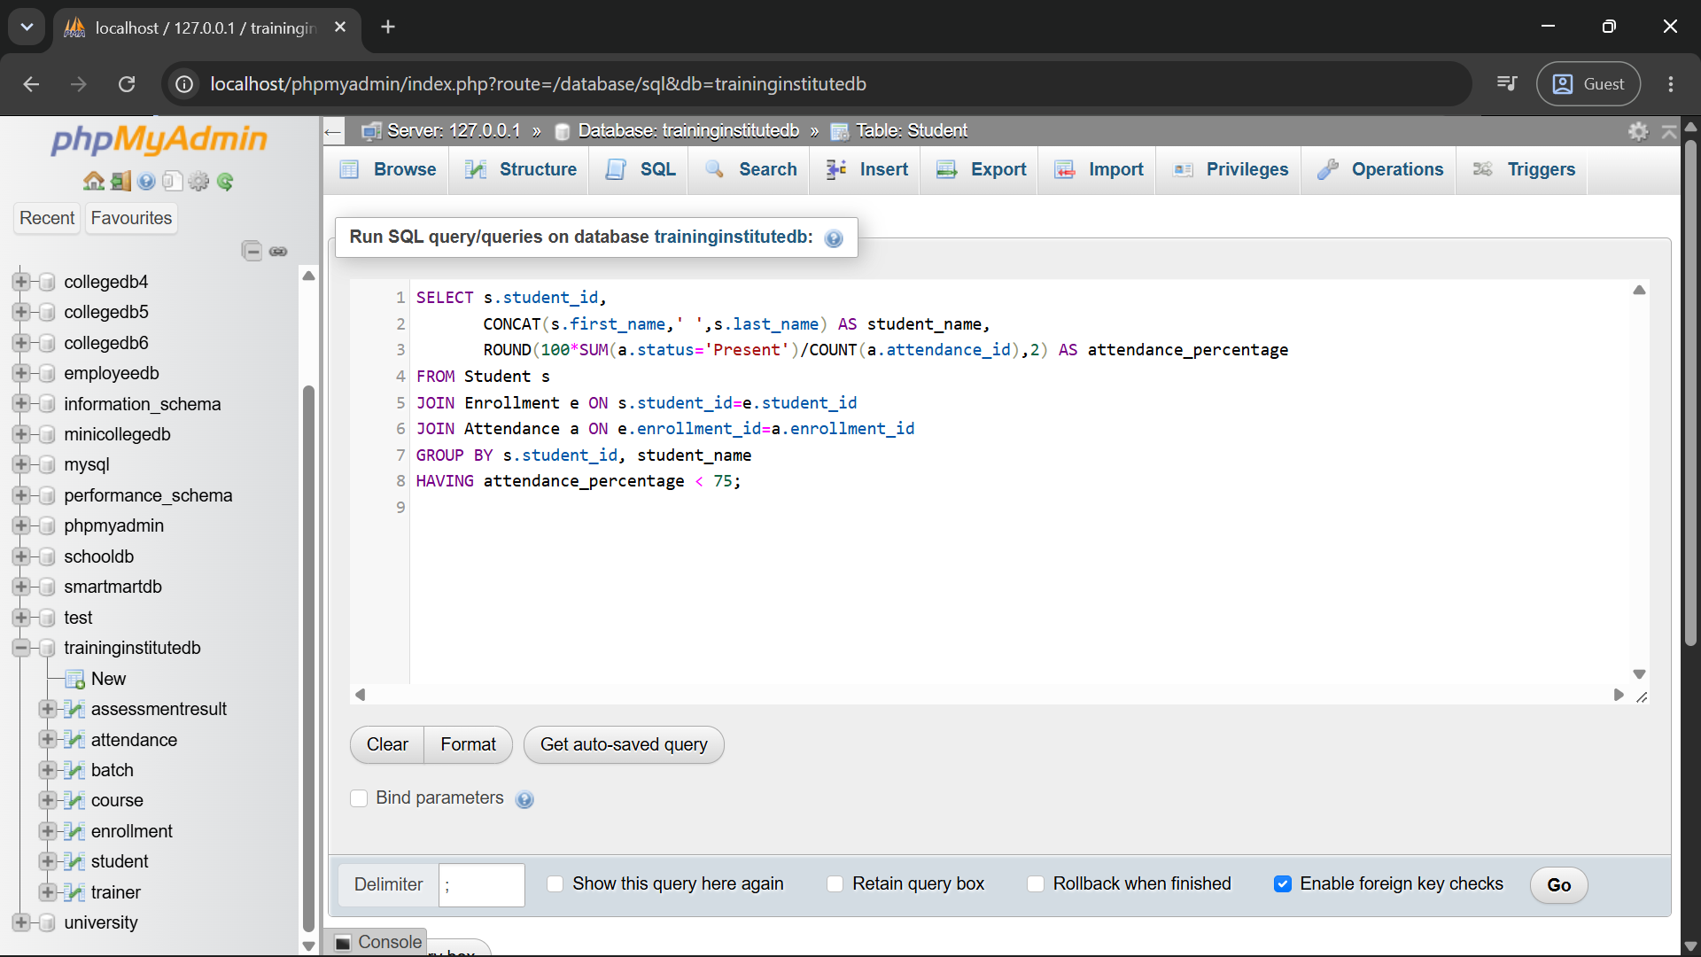
SELECT s.student_id,
CONCAT(s.first_name,' ',s.last_name) AS student_name,
ROUND(100*SUM(a.status='Present')/COUNT(a.attendance_id),2) AS attendance_percentage
FROM Student s
JOIN Enrollment e ON s.student_id=e.student_id
JOIN Attendance a ON e.enrollment_id=a.enrollment_id
GROUP BY s.student_id, student_name
HAVING attendance_percentage < 75;

Q6. Find the average assessment score for each batch.
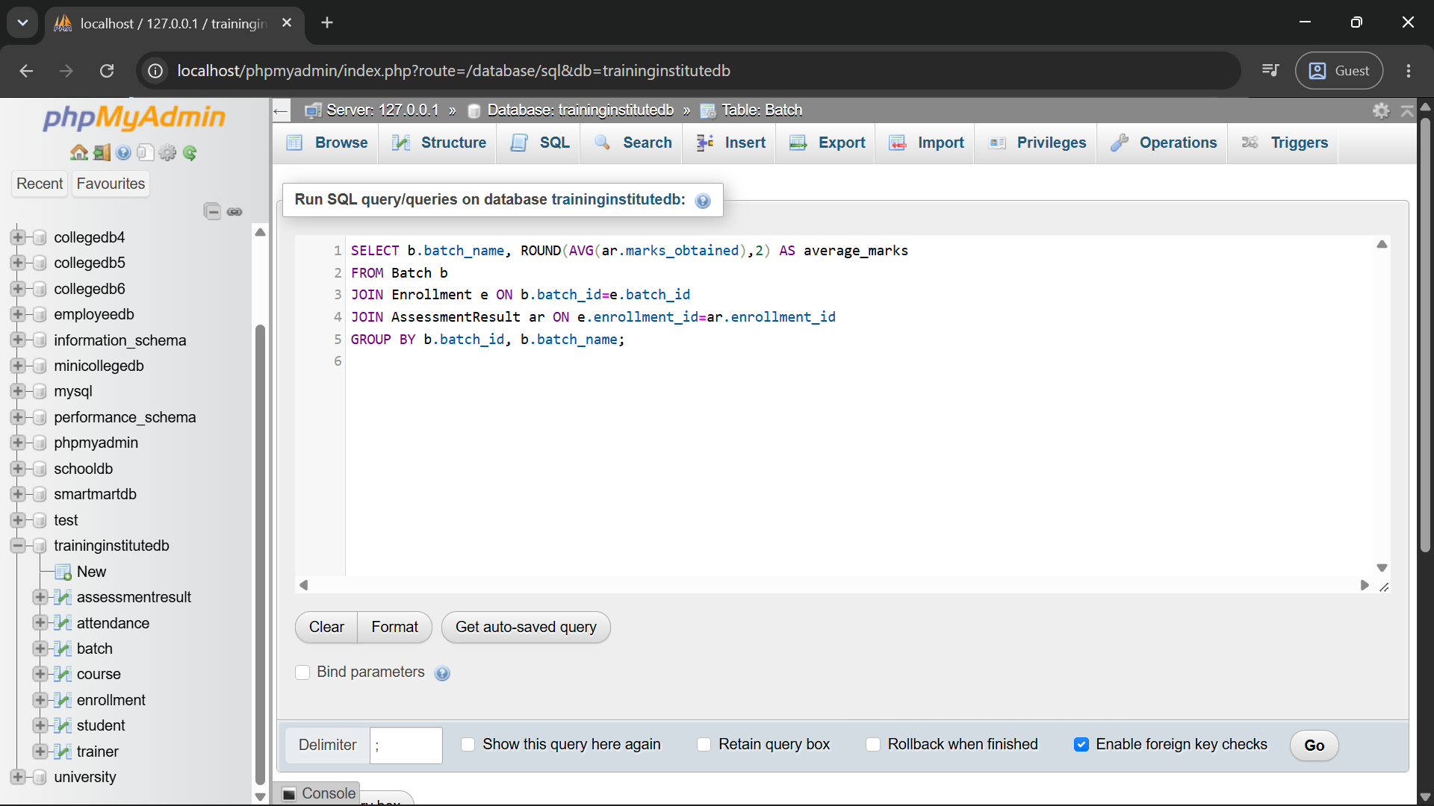
SELECT b.batch_name, ROUND(AVG(ar.marks_obtained),2) AS average_marks
FROM Batch b
JOIN Enrollment e ON b.batch_id=e.batch_id
JOIN AssessmentResult ar ON e.enrollment_id=ar.enrollment_id
GROUP BY b.batch_id, b.batch_name;

Q7. Identify the highest-performing student in every batch.
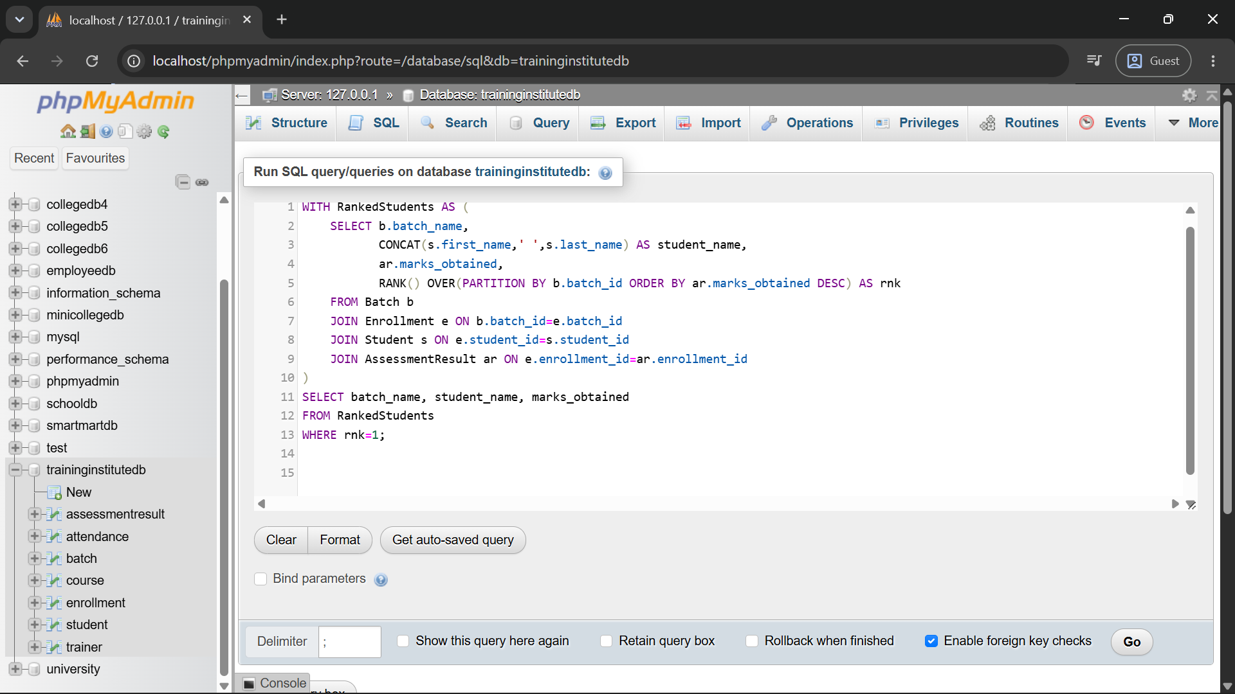
WITH RankedStudents AS (
SELECT b.batch_name,
CONCAT(s.first_name,' ',s.last_name) AS student_name,
ar.marks_obtained,
RANK() OVER(PARTITION BY b.batch_id ORDER BY ar.marks_obtained DESC) AS rnk
FROM Batch b
JOIN Enrollment e ON b.batch_id=e.batch_id
JOIN Student s ON e.student_id=s.student_id
JOIN AssessmentResult ar ON e.enrollment_id=ar.enrollment_id
)
SELECT batch_name, student_name, marks_obtained
FROM RankedStudents
WHERE rnk=1;

Q8. Display students who have not attended any session.
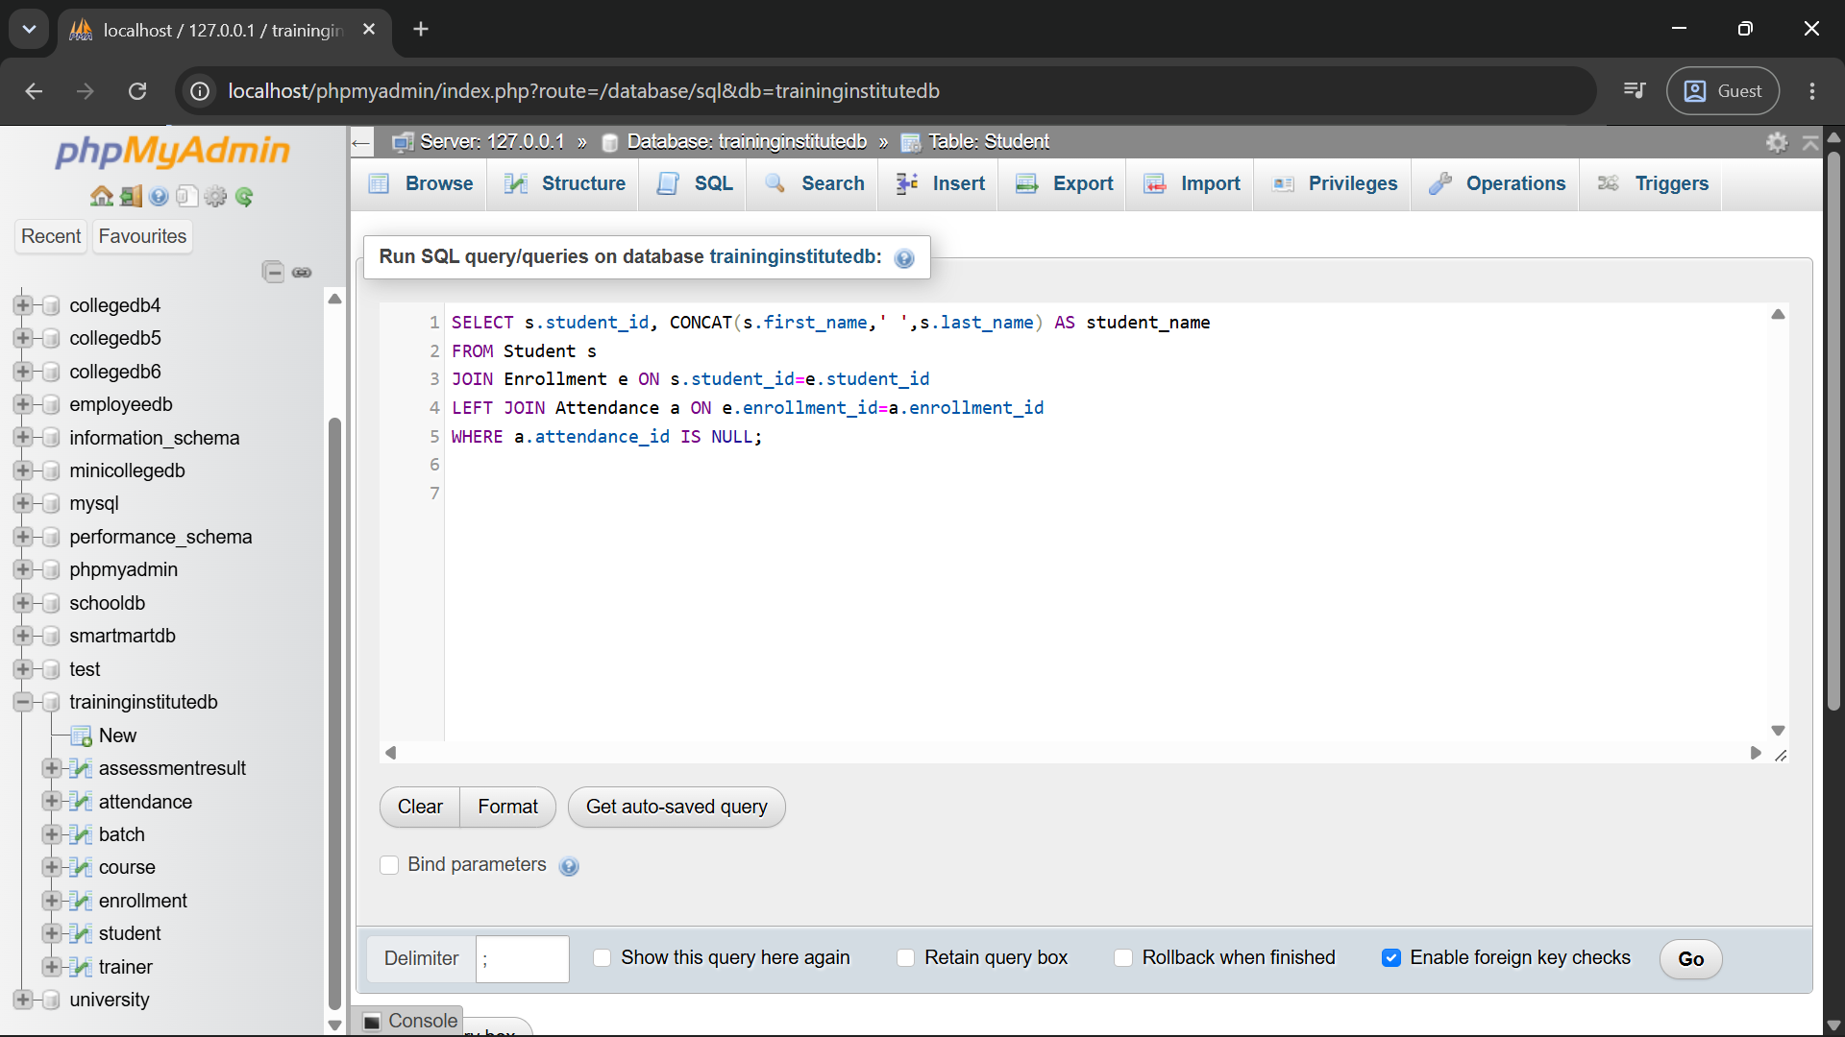
SELECT s.student_id, CONCAT(s.first_name,' ',s.last_name) AS student_name
FROM Student s
JOIN Enrollment e ON s.student_id=e.student_id
LEFT JOIN Attendance a ON e.enrollment_id=a.enrollment_id
WHERE a.attendance_id IS NULL;

Q9. Compare course-wise student performance.
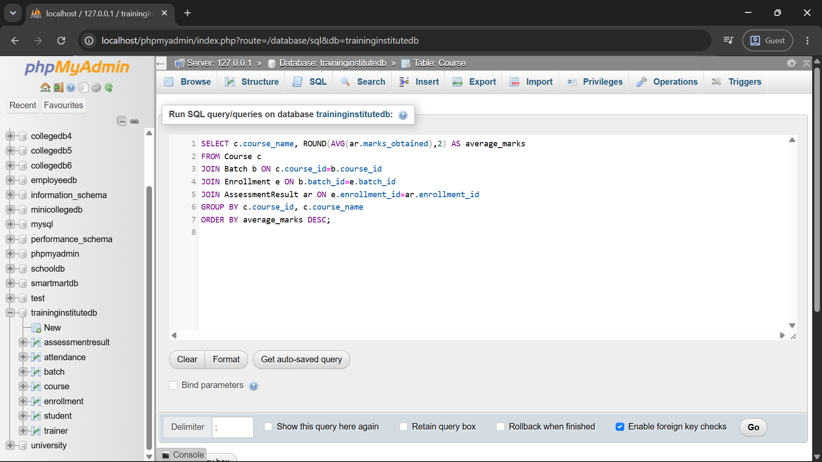
SELECT c.course_name, ROUND(AVG(ar.marks_obtained),2) AS average_marks
FROM Course c
JOIN Batch b ON c.course_id=b.course_id
JOIN Enrollment e ON b.batch_id=e.batch_id
JOIN AssessmentResult ar ON e.enrollment_id=ar.enrollment_id
GROUP BY c.course_id, c.course_name
ORDER BY average_marks DESC;

Q10. Rank students according to assessment results.
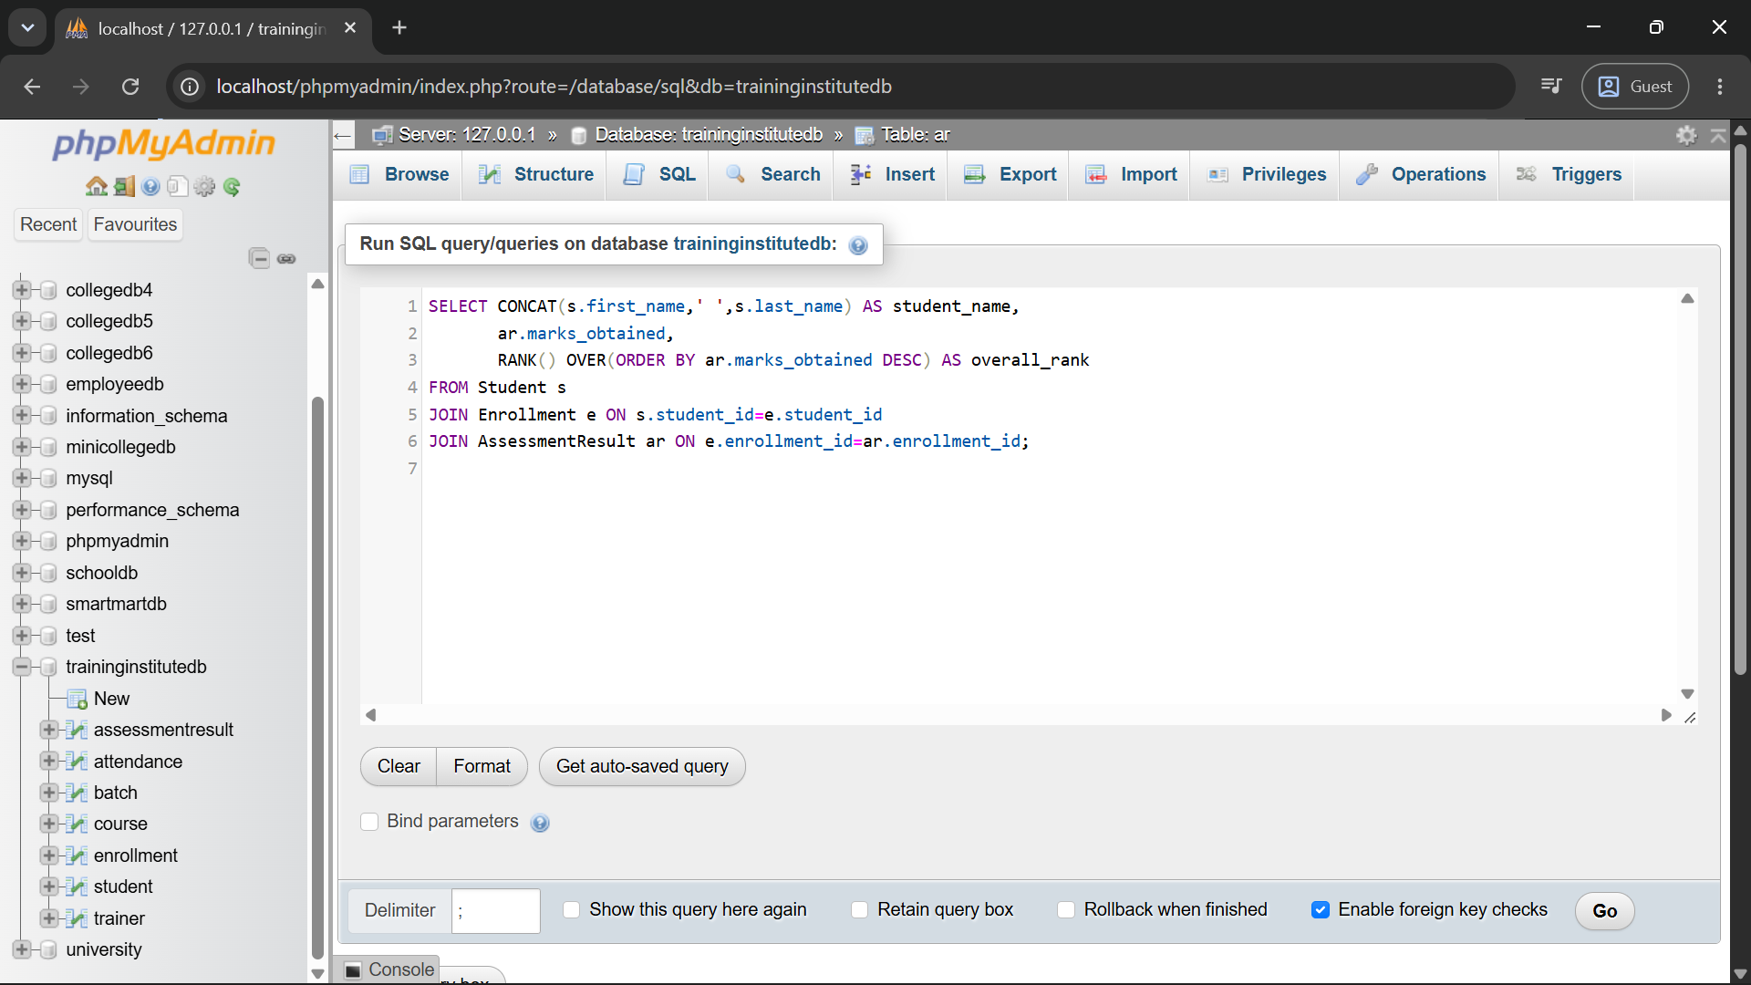
SELECT CONCAT(s.first_name,' ',s.last_name) AS student_name,
ar.marks_obtained,
RANK() OVER(ORDER BY ar.marks_obtained DESC) AS overall_rank
FROM Student s
JOIN Enrollment e ON s.student_id=e.student_id
JOIN AssessmentResult ar ON e.enrollment_id=ar.enrollment_id;

Q11. Find batches with the highest and lowest average attendance.
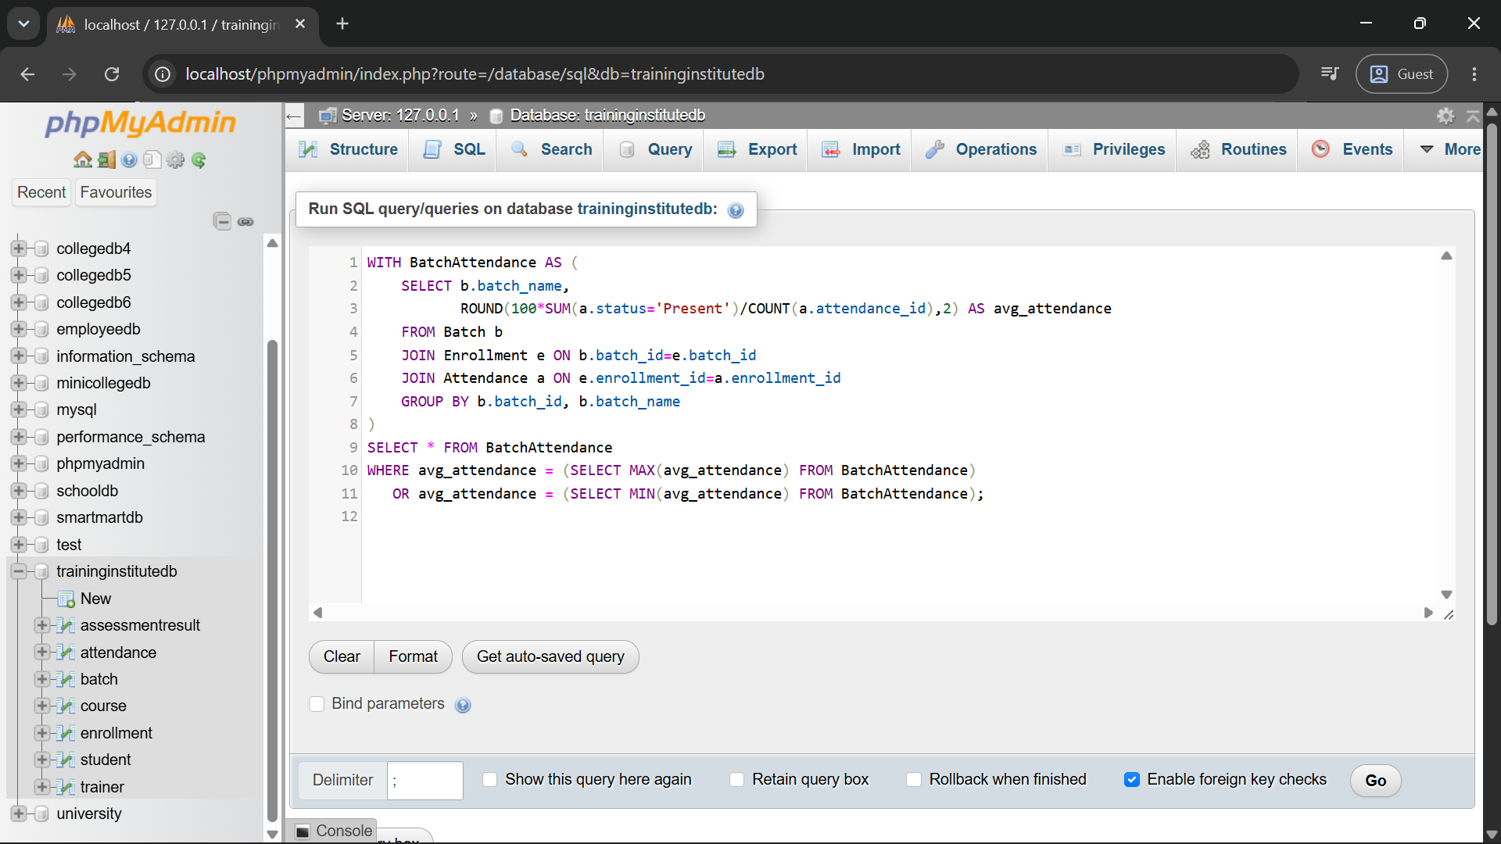
WITH BatchAttendance AS (
SELECT b.batch_name,
ROUND(100*SUM(a.status='Present')/COUNT(a.attendance_id),2) AS avg_attendance
FROM Batch b
JOIN Enrollment e ON b.batch_id=e.batch_id
JOIN Attendance a ON e.enrollment_id=a.enrollment_id
GROUP BY b.batch_id, b.batch_name
)
SELECT * FROM BatchAttendance
WHERE avg_attendance = (SELECT MAX(avg_attendance) FROM BatchAttendance)
OR avg_attendance = (SELECT MIN(avg_attendance) FROM BatchAttendance);

Q12. Generate a student-wise training progress report.
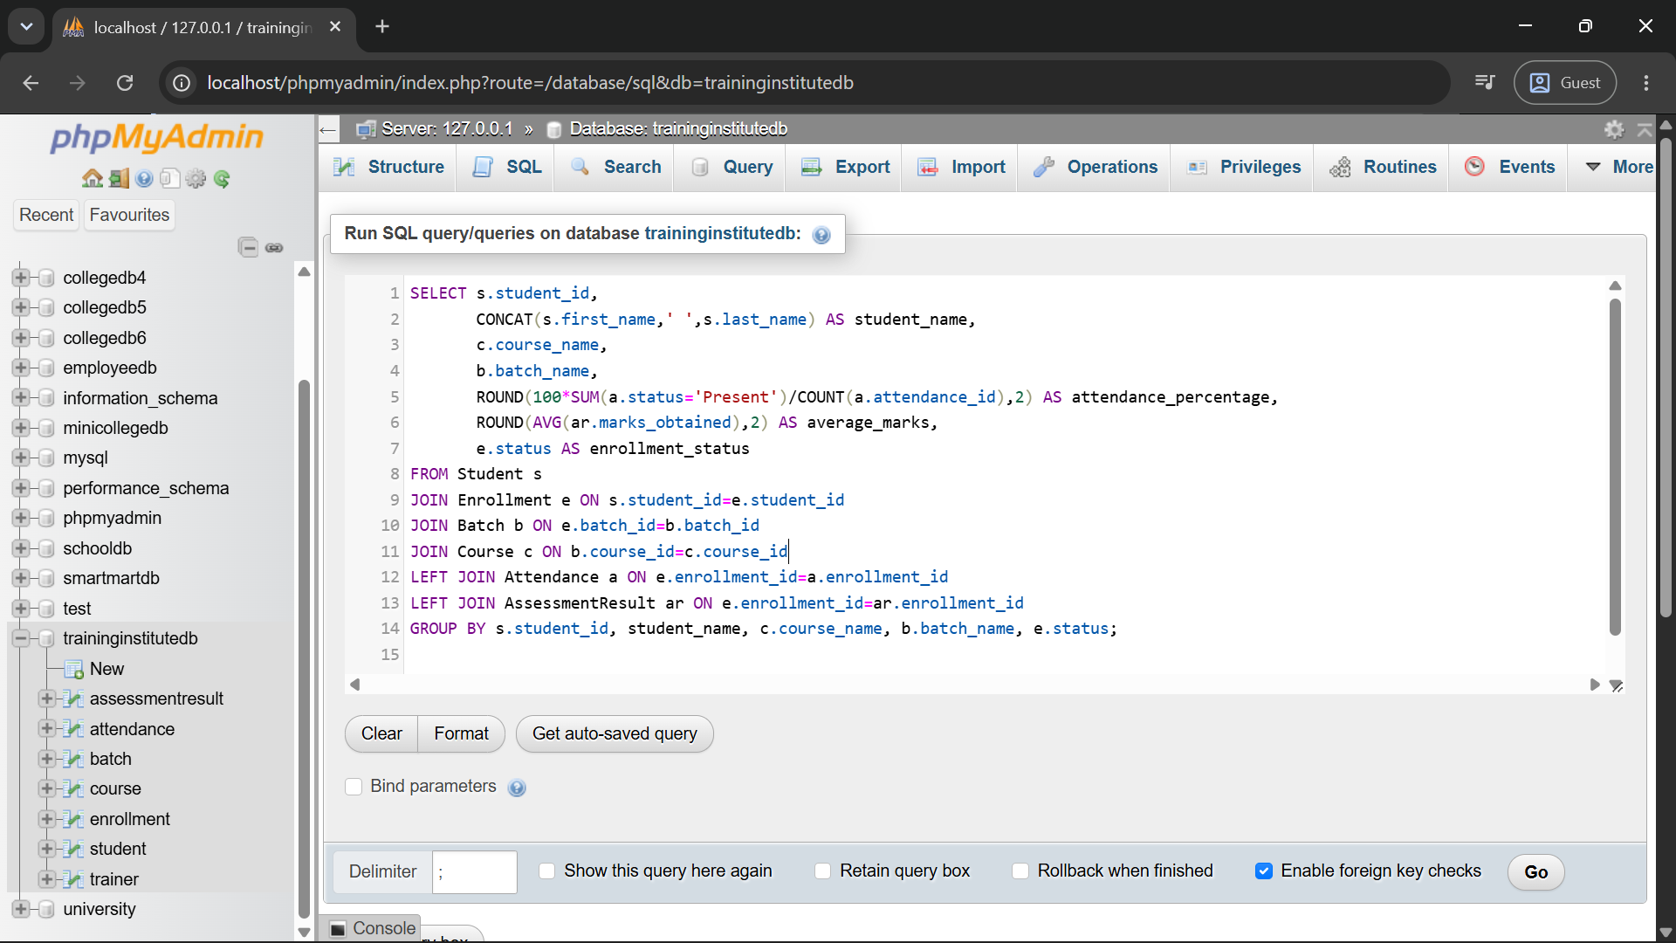
SELECT s.student_id,
CONCAT(s.first_name,' ',s.last_name) AS student_name,
c.course_name,
b.batch_name,
ROUND(100*SUM(a.status='Present')/COUNT(a.attendance_id),2) AS attendance_percentage,
ROUND(AVG(ar.marks_obtained),2) AS average_marks,
e.status AS enrollment_status
FROM Student s
JOIN Enrollment e ON s.student_id=e.student_id
JOIN Batch b ON e.batch_id=b.batch_id
JOIN Course c ON b.course_id=c.course_id
LEFT JOIN Attendance a ON e.enrollment_id=a.enrollment_id
LEFT JOIN AssessmentResult ar ON e.enrollment_id=ar.enrollment_id
GROUP BY s.student_id, student_name, c.course_name, b.batch_name, e.status;

12. Expected Analysis from the Sample Data
Analysis Area | Finding
Course enrollment | Python Programming has 4 enrollments across two batches; Data Analytics with SQL has 3; Web Development has 2; Data Science has 3.
Low attendance | The sample attendance records include students below the 75% threshold, which can be identified using Q5.
Batch performance | Assessment records allow average marks to be calculated and compared batch-wise.
High performers | Scores such as 94, 91 and 88 can be identified through assessment ranking queries.
Training progress | The progress report combines course, batch, attendance, assessment performance, and enrollment status.

13. How the Institute Can Use the Results
- Use enrollment counts to understand demand for each course and batch.
- Use attendance percentages to identify students who may need follow-up.
- Use assessment averages and rankings to identify strong performance and students who may need additional support.
- Use trainer and batch information to monitor course delivery.
- Use the student-wise progress report to support academic and training decisions.

14. Required SQL Techniques Demonstrated
Technique | Use in this Project
Joins | Connect Student, Enrollment, Batch, Course, Trainer, Attendance and AssessmentResult.
Aggregate functions | COUNT() and AVG() summarize enrollments and performance.
Subqueries | Compare batch attendance with maximum and minimum values.
Views | Can be used for frequently requested reports such as student-wise progress.
Window functions | RANK() is used for batch-wise and overall student ranking.

15. Conclusion
The Training Institute Management System provides a structured relational database for managing students, trainers, courses, batches, enrollments, attendance, and assessment results. The ER model establishes the required one-to-many relationships and foreign keys maintain referential integrity. The business queries demonstrate how MySQL can convert operational records into useful reports about enrollment, attendance, and student performance.

16. Submission Checklist
☐ ER diagram showing all seven required tables and relationships.
☐ Primary key for every table.
☐ Foreign keys for all required relationships.
☐ MySQL database and table creation script.
☐ Realistic sample data in all tables.
☐ Business queries using joins, aggregates, subqueries and window functions where suitable.
☐ Analysis, insights, and conclusion.
☐ Separate MySQL script file included with this report.
Prepared according to Assignment No. 12 of the supplied DBMS workbook.

17. Final Relational Schema Summary
COURSE(course_id PK, course_name, duration_weeks, fee, course_level)
TRAINER(trainer_id PK, trainer_name, email, specialization, experience_years)
BATCH(batch_id PK, batch_name, course_id FK, trainer_id FK, start_date, end_date, timing, max_capacity)
STUDENT(student_id PK, first_name, last_name, email, phone, city, registration_date)
ENROLLMENT(enrollment_id PK, student_id FK, batch_id FK, enrollment_date, status)
ATTENDANCE(attendance_id PK, enrollment_id FK, session_date, status)
ASSESSMENT_RESULT(result_id PK, enrollment_id FK, assessment_name, assessment_date, marks_obtained, max_marks)
The relational schema is consistent with the ER model: every strong entity has its own primary key, and every required one-to-many relationship is implemented through a foreign key on the many-side table.

